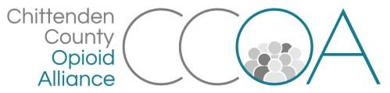
Working Recovery Action Team
128 Lakeside Ave, Suite 106, Burlington
October 8th, 11:00-12:00

AGENDA

Topics | Notes | Time
Welcome & Intros |  | 5 mins
Focus group planning | - Planning for a focus group with employers on 10/23 at the Albany College of Pharmacy in Colchester  - Discuss questions for employers and format of meeting (see handout) | 40 mins
Updates | - Opportunity for an ed on employment  - VBSR Conference 10/25  - Others? | 15 min.
***Next meeting=November 12th, 128 Lakeside, Ste 106***

