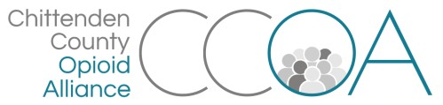
Working Recovery Action Team
38 S. Winooski Ave, Burlington
March 8th, 10:00-11:00

AGENDA

Topics | Notes | Time
Welcome & Intros |  | 5 mins
Toolkit Draft & Video | - Update on the status of the toolkit and video for employers  - Discussion about this effort evolving into a Worksite Wellness initiative  - Possible opportunity for a pilot in Chittenden County | 30 mins
Discussion/updates | - Upcoming events to share? | 1o min.
Next meeting: April 12th 9:00-11:00
First Congregational Church, 38 S. Winooski Ave. Burlington

