Working Recovery Action Team 38 S. Winooski Ave., Burlington
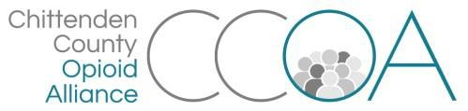

April 12, 2019, 10:00-11:00am

AGENDA

Topics | Notes | Action Steps | Time
Welcome & Introductions |  |  | 10 mins.
Update about proposal with VR and EAP |  |  | 15 mins.
Discuss soft launch from meeting with United Way, creating coalition of HR/HR-professions |  |  | 20 mins.
Toolkit update |  |  | 15 mins.
Next meeting: May 10th 9:00-11:00
First Congregational Church, 38 S. Winooski Avenue, Burlington

