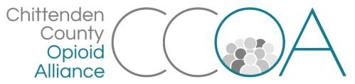
Working Recovery Action Team
128 Lakeside Ave, Suite 106, Burlington
August 13th, 11:00-12:00

AGENDA

Topics | Notes | Time
Welcome & Intros |  | 5 mins
Toolkit for Employers and Employees | - Update on "Employment Video" from Aimee Marti  - Overview of the NH Recovery Friendly Workplace campaign  - Discussion and feedback about opportunities here in VT to do a similar campaign  - Toolkit items - what do we want to offer employers/employees? | 30 mins
Grant funding | - Update on grants to nonprofits | 5 mins
Updates | - October meeting with employers  - Others? | 15 min.
***Next meeting=September 10th, 128 Lakeside, Ste 106***

